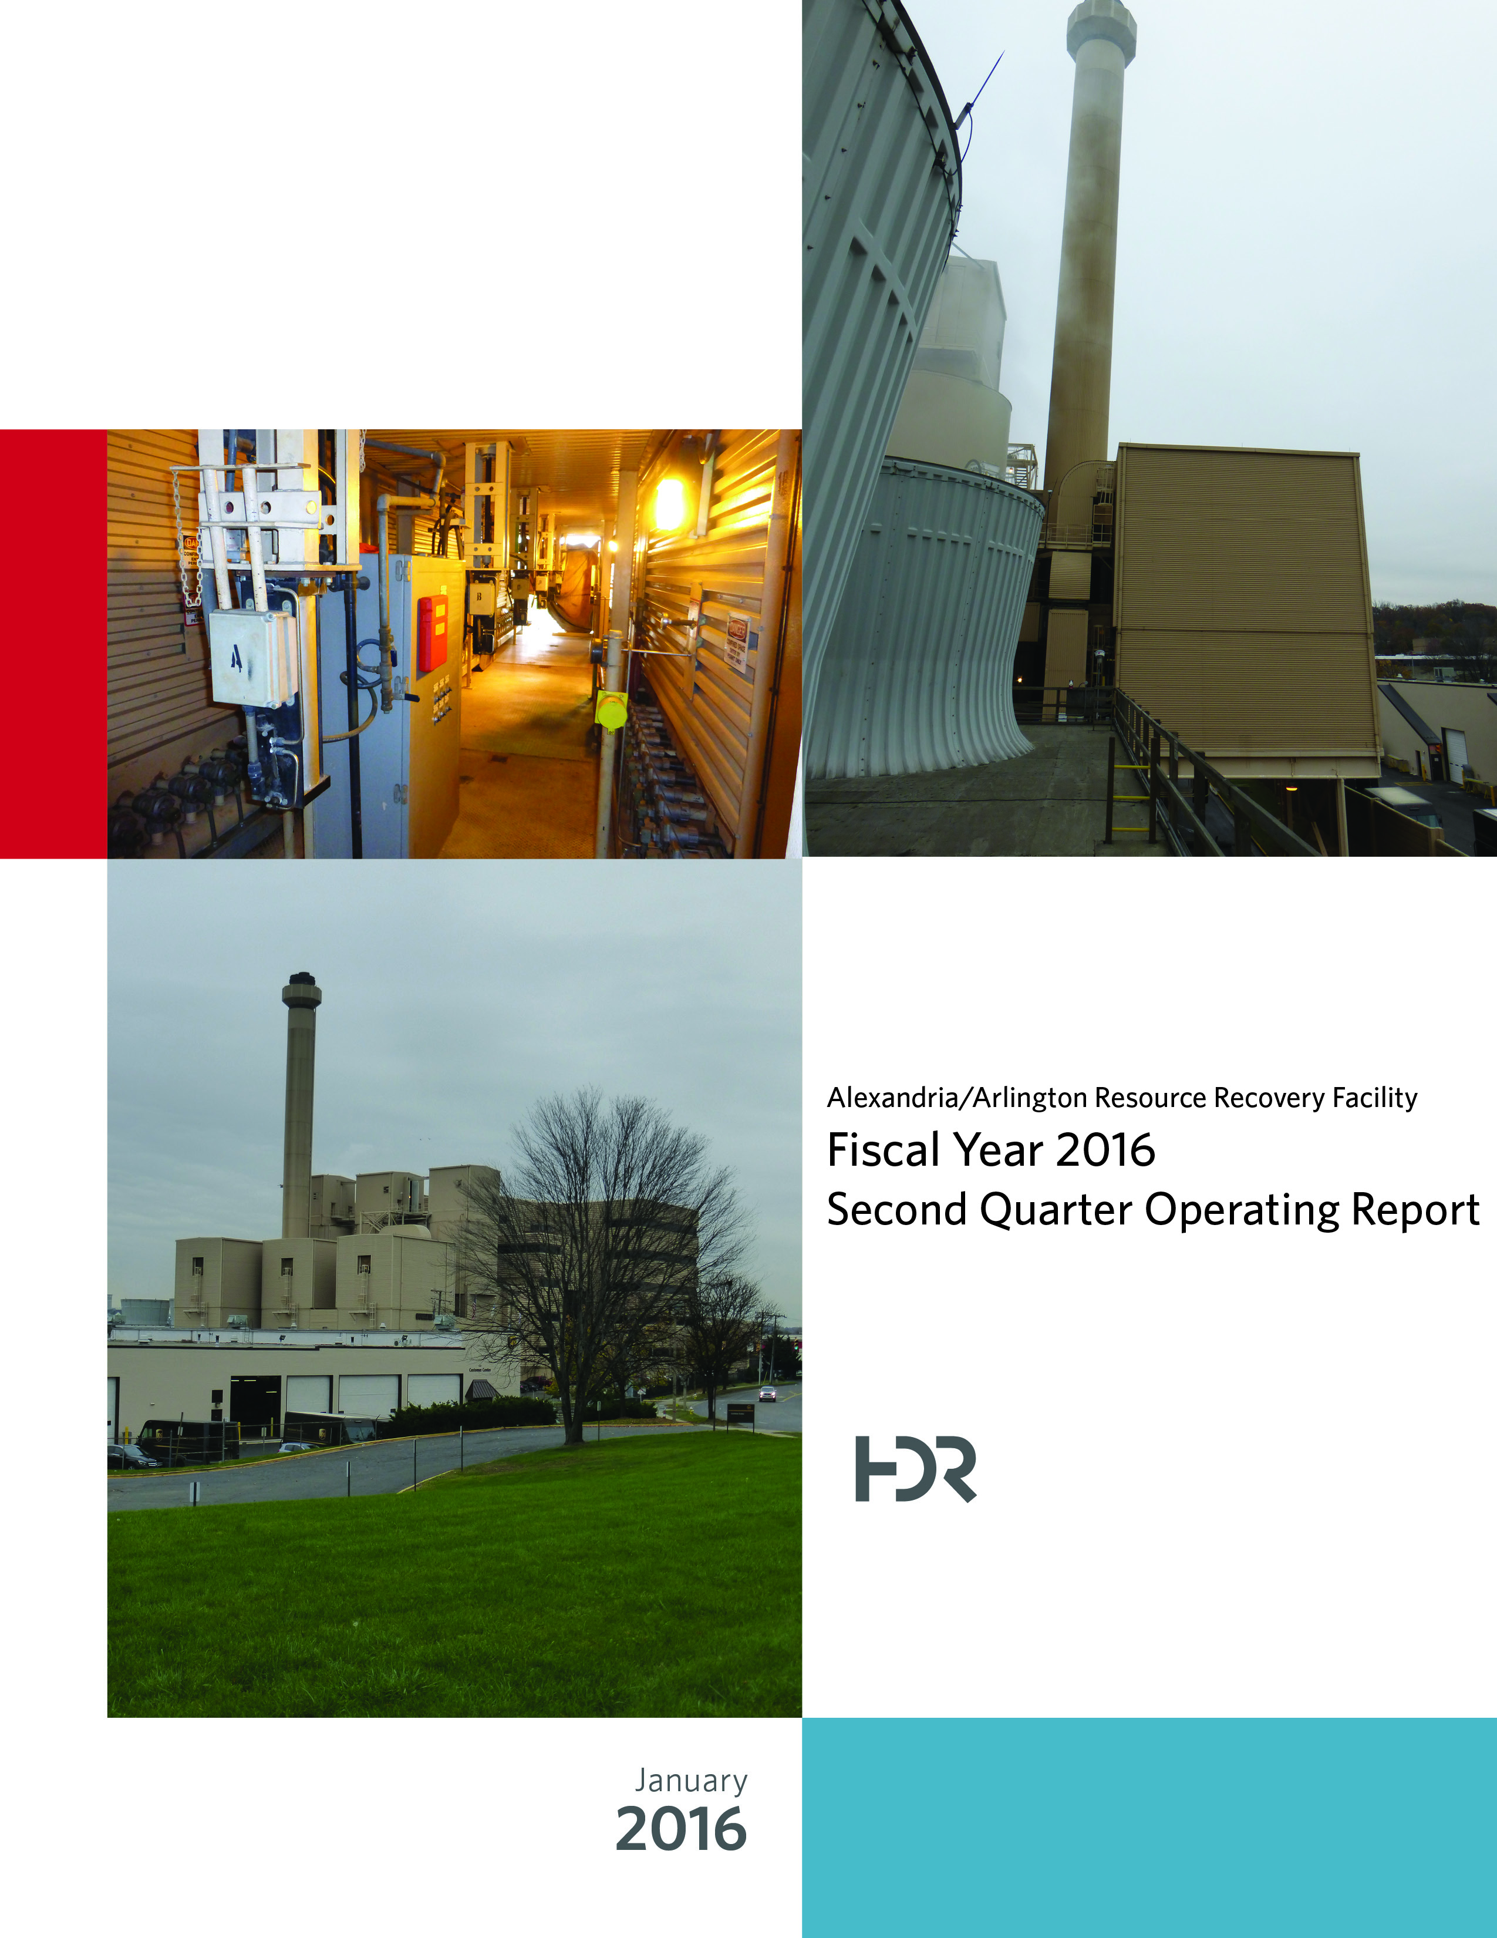

Table of Contents

Section No. Page No.

1.0 Purpose of Report 4

2.0 Executive Summary 4

3.0 Facility Inspection and Records Review 5

4.0 Facility Performance 9

4.1 Utility and Reagent Consumptions 22

4.2 Safety & Environmental Training 23

5.0 Facility Maintenance 24

5.1 Availability 25

5.2 Downtime Summary 26

5.3 Facility Housekeeping 28

6.0 Environmental 29

6.1 Nitrogen Oxide Emissions 29

6.2 Sulfur Dioxide Emissions 30

6.3 Carbon Monoxide Emissions 30

6.4 Opacity 30

6.5 Daily Emissions Data 30

6.6 Ash System Compliance 30

APPENDIX A FACILITY CEMS DATA 33

APPENDIX B PHOTOS 37

List of Tables

Table No. Page No.

Table 1: Summary of Audit Report Deficiencies 7

Table 2: Quarterly Performance Summaries 15

Table 3: Waste Delivery Classification 16

Table 4: Facility Utility and Reagent Consumptions 22

Table 5: Quarterly Facility Unit Availabilities 26

Table 6: Boiler Downtime – Q2FY16 27

Table 7: Turbine Generator Downtime – Q2FY16 27

Table 8: Facility Housekeeping Ratings – August 2015 28

Table 9: Quarterly Environmental Excursions 29

Table 10: Comparison of Statistical Results and Regulatory Thresholds for Metal Analytes 31

Table 11: Unit #1 Monthly Summary for Reportable Emissions Data 34

Table 12: Unit #2 Monthly Summary for Reportable Emissions Data 35

Table 13: Unit #3 Monthly Summary for Reportable Emissions Data 36

List of Charts

Chart No. Page No.

Chart 1: Tons of Waste Processed 9

Chart 2: Tons of Ash Produced per Ton of Waste Processed 10

Chart 3: Ferrous Recovery Rate 11

Chart 4: Steam Production 12

Chart 5: 12-Month Rolling Steam Production 12

Chart 6: Steam Production Rate 13

Chart 7: Calculated Waste Heating Value 14

Chart 8: Cumulative Total Waste Delivery 17

Chart 9: Gross Electrical Generation 17

Chart 10: Gross Conversion Rate 18

Chart 11: Net Conversion Rate 19

Chart 12: Net Conversion Rate 20

Chart 13: Gross Turbine Generator Conversion Rate 20

Chart 14: Net Turbine Generator Conversion Rate 21

Chart 15: Ash Toxicity Characteristic Leaching Procedure (TCLP) Results 31

Chart 16: Quarterly Ash Test Results 32

List of Figures

Figure No. Page No.

Figure 1: Ash Trailers (typical of 3) have a damaged top pressure-treated wood rail (2”x6”) – New Deficiency 38

Figure 2: Ceiling panels corroded, above Condensate Make-up Tank – Painting Item – New Deficiency 38

Figure 3: Pressure treated support split at bolt, on Cooling Tower Access Stairs – New Deficiency 38

Figure 4: Cooling Towers from SDA Penthouse 38

Figure 5: New Opacity Monitor being installed on Boiler No. 3 38

Figure 6: New Opacity Monitor Panel inside CEMS Enclosure 38

Figure 7: Ferrous Magnet – No Issues Observed 39

Figure 8: Boiler No. 3 Grate - Offline for Fall Outage 39

Figure 9: Outage Materials at Grate Access Elevation 39

Figure 10: Refractory Tile awaiting installation 39

Figure 11: Ash Trailer Canopy 39

Figure 12: Tipping Floor Entrance – Recently resurfaced – No Issues Observed 39

Figure 13: Metal Drop-off 40

Figure 14: Facility Scales – No Issues Observed 40

Figure 15: Citizen’s Drop-Off 40

Figure 16: Drainage Grate at Truck Entrance to Facility – New epoxy application being tested 40

Figure 17: General Facility View from east looking west 40

Figure 18: General Facility View – Front of Facility Facing Eisenhower 40

Figure 19: General Facility View – From west looking east 41

Figure 20: Dolomitic Lime Silo – No Issues Observed 41

Figure 21: Tipping Floor – No Issues Observed 41

Figure 22: Economizers & Spray Dryer Absorbers (SDAs) 41

Figure 23: Refuse Pit – From north looking south 41

Figure 24: Baghouse Compartment Aisle – No Issues Observed 41

**Definition of Abbreviations & Acronym**

|  |  |
| --- | --- |
| Abbreviation/Acronym | Definition |
| APC | Air Pollution Control |
| Apr | April |
| Aug | August |
| Avg | Average |
| Btu | British thermal unit |
| CAAI | Covanta Alexandria Arlington, Inc. |
| CEMS | Continuous Emissions Monitoring System |
| CO | Carbon Monoxide |
| Dec | December |
| ECOM | Emergency Communications |
| Feb | February |
| FMG | Facility Monitoring Group |
| FY | Fiscal Year |
| gal | Gallon |
| GAT | Guaranteed Annual Tonnage |
| HCl | Hydrochloric (Hydrogen Chlorides) |
| HDR | HDR Engineering Inc |
| ID | Induced Draft |
| Jan | January |
| Jul | July |
| Jun | June |
| klbs | Kilo-pounds (1,000 lbs) |
| kWhr | Kilowatt hours (1,000 watt-hours) |
| lbs | Pounds |
| LOA | Letter of Agreement |
| Mar | March |
| Max | Maximum |
| May | May |
| Min | Minimum |
| MSW | Municipal Solid Waste |
| MWhr | Megawatt hours |
| No | Number |
| NOV | Notice of Violation |
| Nov | November |
| NOx | Nitrogen Oxide |
| Oct | October |
| OSHA | Occupational Safety and Health Administration |
| PDS | Potomac Disposal Services |
| ppm | Parts per million |
| ppmdv | Parts per million dry volume |
| PSD | Prevention of Significant Deterioration |
| Q1 | First Quarter |
| Q2 | Second Quarter |
| Q3 | Third Quarter |
| Q4 | Fourth Quarter |
| RE | Reportable Exempt |
| RNE | Reportable Non-Exempt |
| SDA | Spray Dryer Absorber |
| Sep | September |
| SO2 | Sulfur Dioxide |
| TCLP | Toxicity Characteristic Leaching Procedure |
| VADEQ | Virginia Department of Environmental Quality |
| WL | Warning Letter |
| yr | Year |
| YTD | Year to date |

Alexandria/Arlington Waste-to-Energy Facility

Second Quarter Operating Report – Fiscal Year 2016

# Purpose of Report

HDR Engineering, Inc. (HDR) was authorized by the Facility Monitoring Group (FMG) to conduct quarterly inspections and provide quarterly reports regarding the operation and maintenance of the Covanta Alexandria/Arlington Waste-to-Energy Facility (Facility) for the 2016 calendar year. This report is prepared for the second quarter of the 2016 fiscal year and summarizes Facility operations between October 1, 2015 and December 31, 2015. This report identifies the fiscal year beginning on July 1, 2015 as FY16 and the quarter beginning on October 1, 2015 as Q2FY16.

This report is based upon HDR’s experience in the waste-to-energy industry, upon site observation visits and previous reports provided by HDR, and upon data provided by Covanta Alexandria / Arlington, Inc. (CAAI), the Facility owner and operator.

# Executive Summary

CAAI operated the Facility in an acceptable manner and in accordance with established waste-to-energy industry practices during Q2FY16. The operation of the Facility, maintenance, safety, and overall cleanliness continue to be above average. Environmental performance was acceptable with one (1) reportable environmental excursion throughout the quarter.

During Q2FY16, the Facility experienced one (1) instance of unscheduled downtime for the boilers totaling 7.1 hours, and no unscheduled downtime for the turbine generators. Beginning October 10, 2015, Boiler No. 2 experienced 112.0 hours of downtime for scheduled maintenance, and beginning November 7, 2015 Boiler No. 3 experienced 121.5 hours for scheduled maintenance. Note that Boiler No. 1 scheduled maintenance was conducted last quarter in the month of September (Q1FY16). During Q2FY16, the boilers experienced two (2) instances of standby time totaling 84.8 hours, and Turbine Generator No. 1 experienced three (3) instances of standby time totaling 173.1 hours. Note that standby time isn’t factored into reported availability. A detailed listing of downtime is provided in Section 5.2 of this report.

Average waste processed during the quarter was 930.1 tons per day, or 95.4% of nominal facility capacity. Waste deliveries averaged 928.9 tons per day, which is 0.1% lower than the burn rate. The capacity utilization of 95.4% compares favorably to industry averages, which are generally in the 88% to 92% range.

Performance trends for various measurements are presented in Section 4. In general, the Facility continues to demonstrate reasonable consistency in month to month performance throughout the most recent three-year period tracked for detailed comparisons.

During the quarter, MSW processed increased 0.1% from the corresponding quarter in FY15; steam production decreased 1.1%, and electricity generated (gross) decreased 2.7% from the corresponding quarter in FY15. The decrease in steam generation was attributable to the decrease (1.0%) in the calculated average waste heating value, offset by less downtime (31.5 fewer hours) experienced by the boilers. The decrease in gross electrical generation in Q2FY16 as compared to Q2FY15 is partially attributable to the decrease in steam production, offset by less downtime (6.2 fewer hours) experienced by the Turbine Generators.

# Facility Inspection and Records Review

In November 2015, HDR met with the Facility management and other plant personnel to discuss Facility operations, and maintenance, acquire Facility data and reports, perform an independent visual inspection of the operating Facility, photograph areas of interest, and perform a review of recent Facility activity. This visit was coordinated with the scheduled FMG meeting. At the time of the inspection, HDR reviewed CAAI records, discussed performance issues with CAAI staff, and provided a verbal report and performance statistics at the FMG meeting. HDR maintains a running tabulation of the status of corrective actions and plant performance trends. CAAI provides the following documents for each month:

* Facility Monthly Operating Reports
* Monthly Continuous Emissions Monitoring System (CEMS) Reports

Table 1 summarizes maintenance, repair, and plant condition issues reported during this and prior audit reporting periods. An “A” indicates an issue of the highest priority and worthy of immediate attention. Such items are usually safety or operability issues. A “B” indicates that the issue needs to be dealt with as quickly as possible, but is not urgent. These items will usually result in a process improvement or will help avoid future “urgent” issues. A “C” indicates that the issue should be dealt with at the earliest convenience, but is not a priority issue. This category might include issues related to aesthetics, non-urgent maintenance, or housekeeping improvements which are not safety related.

Table 1: Summary of Audit Report Deficiencies

*A is highest priority & demands immediate attention: B needs attention, but is not urgent; C can be addressed at earliest opportunity & is not urgent.

| Item No. | Audit Report Deficiencies | Issue Reported | Priority* | HDR Recommendation | Status | Open / Closed |
| --- | --- | --- | --- | --- | --- | --- |
| 1 | Concrete to roadway drain at truck entrance damaged – exposing reinforcing bar | May 2014 | C | Repair damaged concrete | **CAAI reports that it is experimenting with epoxy-based material to cover the exposed rebar to avoid significant cutting of the surrounding concrete.** | Open |
| 2 | Corrosion on ceiling panels in Turbine Generator Enclosure | August 2014 | C | Sand, Prime, Paint and Preserve, and replace deteriorated panels as necessary | **HDR observed the corroded/deteriorated sections had been primed, but no panels were replaced. CAAI reports that it plans to replace panels in 1 to 2 years.** | Open |
| 3 | Corrosion on ceiling panels in Turbine Generator Enclosure (Alternate Location) | August 2014 | C | Sand, Prime, Paint and Preserve, and replace deteriorated panels as necessary | **HDR observed the corroded/deteriorated sections had been primed, but no panels were replaced. CAAI reports that it plans to replace panels in 1 to 2 years.** | Open |
| 4 | Deteriorated purlin east wall in Tipping Floor Enclosure | November 2014 | C | Replace deteriorated purlin | **CAAI reports that it will replace the entire east wall of the Tipping Floor Enclosure as a 2016 Budget Item.** | Open |
| 5 | Damaged curbing northeast corner of Facility near Citizen’s Drop-off | November 2014 | C | Repair curbing | **Status Unchanged** | Open |
| 6 | Damaged curbing west side of Cooling Towers | November 2014 | C | Repair curbing | **Status Unchanged** | Open |
| 7 | Damaged curbing near Ash Trailer Parking Area | November 2014 | C | Repair curbing | **Status Unchanged** | Open |
| 8 | Panels on east wall in Charging Floor damaged | February 2015 | C | Replace damaged wall panels | **Status Unchanged** | Open |
| 9 | Rotary Sootblower Gears Exposed (typical of all 3 boilers) at Crane Pulpit Elevation | May 2015 | A | Install protective cages around all sides of exposed gears. | **Complete** | Closed |
| 10 | Induced Draft Fan No. 1 Lagging deteriorated, west side of CEMS Enclosure | May 2015 | C | Replace deteriorated Induced Draft Fan Lagging | **Status Unchanged** | Open |
| 11 | Emergency light fixture, east side of Tipping Floor, not functioning in test mode | August 2015 | A | Repair emergency light | **Complete** | Closed |
| 12 | Pot hole, southwest corner of Ash Trailer Canopy | August 2015 | C | Repair road surface | **Status Unchanged** | Open |
| 13 | Ash Trailers (typical of 3) have a damaged top pressure-treated wood rail (2”x6”) – See Figure 1 (Appendix B) | November 2015 | C | Contact ash hauling company and request repairs be made to ash trailers | **Status Unchanged** | Open |
| 14 | Ceiling panels corroded, above Condensate Make-up Tank – Painting Item – See Figure 2 (Appendix B) | November 2015 | C | Conduct proper painting preservation measures | **Status Unchanged** | Open |
| 15 | Pressure treated support split at bolt, on Cooling Tower Access Stairs – See Figure 3 (Appendix B) | November 2015 | A | Inspect entire Cooling Tower Access Stairway and replace split supports as needed | **Status Unchanged** | Open |

# Facility Performance

Monthly operating data provided by CAAI indicates that 85,572 tons of MSW were processed during Q2FY16, and a total of 85,546 tons of MSW including 2,147 tons of Special Handling Waste were received. Total ash production during the quarter was 17,669 tons, which represents 20.6% of the waste processed. The average uncorrected steam production rate for Q2FY16 was 3.07 tonssteam/tonwaste, which is nearly identical (0.2% less) to the corresponding quarter in FY15. The decrease in this metric correlates with the decrease (1.0%) in calculated average waste heating value that was experienced in Q2FY16, as compared to Q2FY15.

Chart 1: Tons of Waste Processed

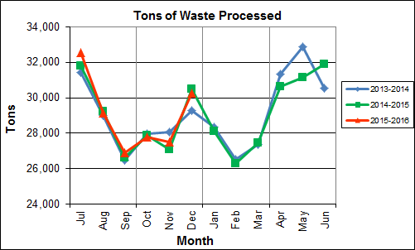

Chart 1 illustrates that Q2FY16 waste processed was slightly higher (0.1%) than the corresponding quarter, Q2FY15.

CAAI reported that 453 tipping floor/MSW internal inspections were conducted during the quarter and four (4) notices of violation (NOVs) were issued to the haulers for the following issues:

* October 2015 – Two (2) NOVs were issued for:
  + Excessive metal unloaded onto the Tipping Floor
  + Large nylon bags of insulation
* November 2015 – One (1) NOV was issued for:
  + Opening turnbuckles before entering the Tipping Floor
* December 2015 – One (1) NOV was issued for:
  + Unacceptable load of sheet rock

Chart 2: Tons of Ash Produced per Ton of Waste Processed

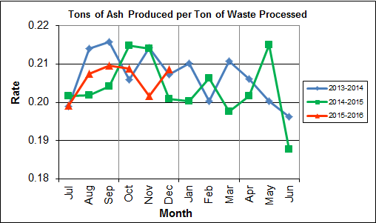

Chart 2 illustrates that the average ash production rate in Q2FY16 was lower (0.4%) at 20.6% of processed waste, compared to the corresponding quarter in FY15 when the rate was 21.0%. Ash production remains in the 20.0% to 21.0% range, as a result of the installation of the “semi-dry” ash discharger spray system in May 2012, and represents less moisture in the ash residue shipped to disposal.

Chart 3: Ferrous Recovery Rate

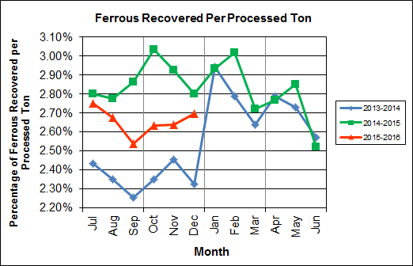

Chart 3 depicts the monthly ferrous metal recovery rate as a percentage of processed MSW tonnage. In Q2FY16, 2,274 tons of ferrous metals were recovered, which is 8.8% lower than the corresponding quarter in FY15 and equivalent to 2.7% of processed waste. CAAI reports that in recent months it was noted that the ferrous recovery rate had decreased and they replaced an end section of the vibrating pan which was worn due to wear from material getting caught between the pan and magnet. However, the metal recovery rate continues to decline. The reason for the substantial decrease remains unexplained.

**Chart 4: Steam Production**

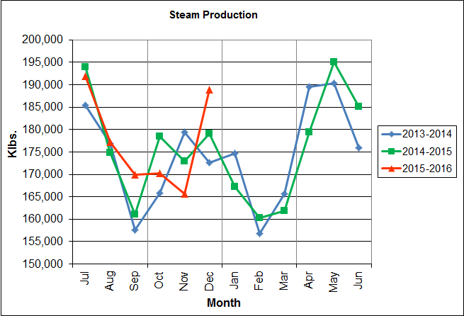

In Chart 4, the total steam production for Q2FY16 was 524,844 klbs., and 1.1% lower than the corresponding quarter in FY15. The decrease in steam production is attributable to the decrease (1.0%) in the calculated average waste heating value, offset by less total downtime (31.5 fewer hours) experienced by the boilers.

Chart 5: 12-Month Rolling Steam Production

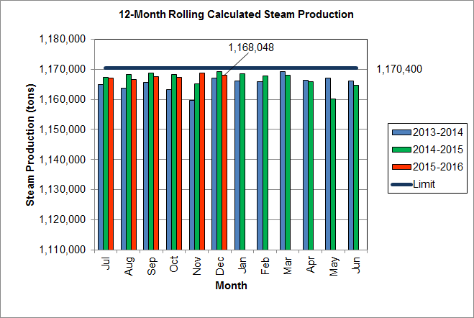

Chart 5 depicts the 12-month rolling steam production total for the period ending in December 2015. According to the Title V permit, the annual steam production for the Facility shall not exceed 1,170,400 tons on the basis of an average value of 3.34 lbs of steam per lb of MSW processed, calculated monthly as the sum of each consecutive 12 month period. The Facility was in compliance with the 12-month rolling steam production total every month in the quarter. The 12-month rolling total for steam production ending in November 2015 was 1,168,048 tons which is 99.8% of the limit. Chart 5 clearly shows that Facility throughput, and in turn, steam and electricity production are being throttled to stay ever so slightly below the steam production limit nearly every month.

Chart 6: Steam Production Rate

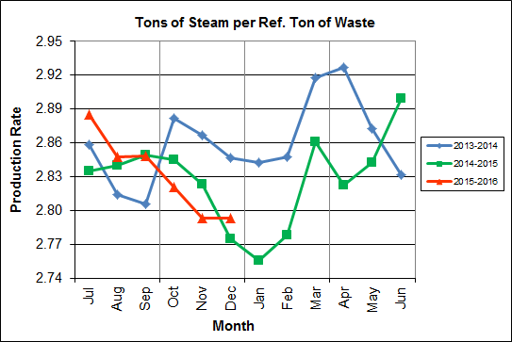

In Chart 6, the conversion of raw waste tonnages into “reference tons” is another way of analyzing steam production, and helps to determine whether changes are related to boiler performance or to fuel issues. “Reference tons” are adjusted to account for the calculated average fuel heating value, so that lower Btu fuel raw tonnages are adjusted upwards and vice versa. In Q2FY16, this metric tracked lower (0.4%) at 2.8 tonssteam/tonref, compared to the corresponding quarter in FY15.

Chart 7: Calculated Waste Heating Value

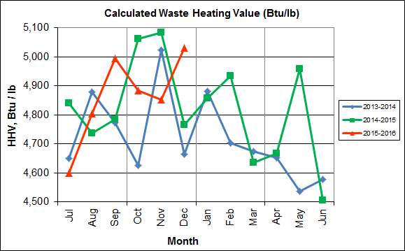

Chart 7 illustrates that Q2FY16 calculated average waste heating value was lower (1.0%) at 4,922 Btu/lb than the corresponding quarter Q2FY15, which averaged 4,970 Btu/lb.

Table 2: Quarterly Performance Summaries

|  |  |  |  |  |  |  |  |  |
| --- | --- | --- | --- | --- | --- | --- | --- | --- |
| Month | | Waste Processed (tons) | Waste Diverted  (tons) | Ash Shipped  (tons) | Special Handling (Supplemental)  (tons) | Ferrous Recovered  (tons) | Steam Produced (klbs) | Net Electrical Generation  (MWhr) |
| **Q2FY14** | **Quarterly Totals** | **85,286** | **0** | **17,833** | **866** | **2,027** | **517,968** | **33,068** |
| October -13 | 27,989 | 0 | 5,763 | 410 | 658 | 165,840 | 11,198 |
| November -13 | 28,043 | 0 | 6,008 | 188 | 689 | 179,483 | 9,705 |
| December -13 | 29,254 | 0 | 6,062 | 268 | 680 | 172,645 | 12,165 |
| **Q2FY15** | **Quarterly Totals** | **85,456** | **0** | **17,912** | **1,814** | **2,492** | **530,413** | **37,911** |
| October -14 | 27,883 | 0 | 5,990 | 521 | 846 | 178,450 | 12,745 |
| November -14 | 27,099 | 0 | 5,799 | 764 | 793 | 172,875 | 12,276 |
| December -14 | 30,474 | 0 | 6,123 | 529 | 853 | 179,088 | 12,890 |
| **Q2FY16** | **Quarterly Totals** | **85,572** | **0** | **17,669** | **2,147** | 2,274 | **524,844** | **36,665** |
| October -15 | 27,796 | 0 | 5,807 | 684 | 732 | 170,190 | 11,899 |
| November -15 | 27,510 | 0 | 5,549 | 676 | 726 | 165,681 | 11,626 |
| December -15 | 30,266 | 0 | 6,313 | 787 | 816 | 188,973 | 13,140 |
| **FY16 YTD Totals** | | **174,144** | **0** | **35,831** | **4,021** | **4,631** | **1,063,947** | **73,727** |
| **FY15 Totals** | | **348,686** | **0** | **71,019** | **5,413** | **9,864** | **2,109,442** | **145,085** |
| **FY14 Totals** | | **349,118** | **0** | **72,071** | **3,549** | **8,922** | **2,091,123** | **143,064** |

Table 2 presents the production data provided to HDR by CAAI for Q2FY16 on both a monthly and quarterly basis. For purposes of comparison, data for Q2FY14 and Q2FY15 are also shown, as well as FY14, FY15 and FY16 YTD totals.

In comparing quarterly totals, the data shows:

* More waste was processed in Q2FY16 than Q2FY15 and Q2FY14
* Less steam was generated in Q2FY16 than Q2FY15 and more than Q2FY14
* Less electricity was generated in Q2FY16 than Q2FY15 and more than Q2FY14
* Significantly more supplemental waste was received in Q2FY16 than Q2FY15 and Q2FY14.

Please note that the total steam generation figures presented in Table 2 do not correlate with the annual steam production limit from the Facility Permit; such limits apply on a 12-month rolling average monthly basis, and not a fiscal year basis. It is also worth noting that the quantity of waste processed during Q2FY16 and FY16 continues to be limited by the steam production permit restrictions (refer to Chart 5).

Table 3: Waste Delivery Classification

|  |  |  |  |  |  |  |  |  |  |  |  |  |  |  |  |
| --- | --- | --- | --- | --- | --- | --- | --- | --- | --- | --- | --- | --- | --- | --- | --- |
|  |  | **Jul** | **Aug** | **Sep** | **Oct** | **Nov** | **Dec** | **Jan** | **Feb** | **Mar** | **Apr** | **May** | **Jun** | **Totals** | **% of Total** |
| **FY12** | **Jurisdiction Waste** | 18,112 | 20,021 | 19,304 | 17,796 | 17,523 | 17,211 | 16,202 | 14,952 | 17,430 | 18,338 | 20,138 | 18,361 | 215,381 | 61.89% |
| **Spot Waste tons** | 8,901 | 13,623 | 13,303 | 9,788 | 11,976 | 11,900 | 10,276 | 10,697 | 10,283 | 10,029 | 11,333 | 10,177 | 132,295 | 38.01% |
| **Supplemental Waste** | 10 | 10 | 34 | 15 | 15 | 21 | 12 | 22 | 15 | 23 | 68 | 91 | 336 | 0.10% |
| **MSW Totals** | **27,023** | **33,654** | **32,641** | **27,599** | **29,514** | **29,132** | **26,490** | **25,672** | **27,729** | **28,390** | **31,539** | **28,629** | **348,012** | **100.00%** |
|  |  |  |  |  |  |  |  |  |  |  |  |  |  |  |  |
| **FY13** | **Jurisdiction Waste** | 19,413 | 18,357 | 16,632 | 17,625( | 18,838 | 16,195 | **-** | **-** | **-** | **-** | **-** | **-** | 107,058 | 30.76% |
| **Spot Waste tons** | 10,516 | 11,326 | 10,610 | 10,317 | 9,330 | 9,558 | **-** | **-** | **-** | **-** | **-** | **-** | 61,656 | 17.72% |
| **City Waste** | **-** | **-** | **-** | **-** | **-** | **-** | 1,683(1) | 1,287 | 1,444 | 2,382 | 2,286 | 1,919 | 11,000 | 3.16% |
| **County Waste** | **-** | **-** | **-** | **-** | **-** | **-** | 2,442(1) | 2,100 | 2,372 | 3,381 | 3,932 | 3,309 | 17,536 | 5.04% |
| **Municipal Solid Waste** | **-** | **-** | **-** | **-** | **-** | **-** | 25,019(1) | 23,637 | 21,661 | 27,066 | 25,794 | 24,930 | 148,107 | 42.56% |
| **Supplemental Waste** | 151 | 11 | 80 | 25 | 234 | 405 | 363 | 365 | 76 | 403 | 281 | 271 | 2,665 | 0.77% |
| **MSW Totals** | **29,928** | **29,683** | **27,241** | **27,942** | **28,167** | **25,753** | **29,507** | **27,388** | **25,552** | **33,231** | **32,293** | **30,429** | **348,022** | **100.00%** |
|  |  |  |  |  |  |  |  |  |  |  |  |  |  |  |  |
| **FY14** | **City Waste** | 2,065 | 1,693 | 1,702 | 1,924 | 1,566 | 1,780 | 1,529 | 1,231 | 1,556 | 2,256 | 2,203 | 1,883 | 21,389 | 6.11% |
| **County Waste** | 3,459 | 3,079 | 2,784 | 3,091 | 2,707 | 2,802 | 2,568 | 1,957 | 2,272 | 3,326 | 3,987 | 3,387 | 35,419 | 10.12% |
| **Municipal Solid Waste** | 26,167 | 23,604 | 22,034 | 23,354 | 21,879 | 25,531 | 23,869 | 22,523 | 23,198 | 25,414 | 27,206 | 24,812 | 289,590 | 82.75% |
| **Supplemental Waste** | 546 | 676 | 248 | 410 | 188 | 268 | 275 | 192 | 231 | 253 | 151 | 110 | 3,548 | 1.01% |
| **MSW Totals** | **32,237** | **29,053** | **26,768** | **28,779** | **26,340** | **30,380** | **28,241** | **25,903** | **27,256** | **31,249** | **33,546** | **30,193** | **349,946** | **100.00%** |
|  |  |  |  |  |  |  |  |  |  |  |  |  |  |  |  |
| **FY15** | **City Waste** | 1,814 | 1,497 | 1,699 | 1,737 | 1,518 | 1,770 | 1,411 | 1,209 | 1,648 | 2,155 | 2,059 | 2,045 | 20,562 | 5.91% |
| **County Waste** | 3,297 | 2,868 | 2,973 | 3,095 | 2,508 | 2,852 | 2,358 | 1,833 | 2,411 | 3,269 | 3,652 | 3,572 | 34,687 | 9.96% |
| **Municipal Solid Waste** | 26,661 | 24,466 | 21,887 | 21,241 | 21,678 | 27,906 | 24,611 | 20,915 | 24,094 | 25,189 | 23,126 | 25,667 | 287,442 | 82.57% |
| **Supplemental Waste** | 141 | 275 | 329 | 521 | 764 | 529 | 389 | 351 | 272 | 613 | 531 | 698 | 5,413 | 1.55% |
| **MSW Totals** | **31,913** | **29,106** | **26,888** | **26,595** | **26,468** | **33,057** | **28,769** | **24,308** | **28,424** | **31,225** | **29,369** | **31,982** | **348,105** | **100.00%** |
|  |  |  |  |  |  |  |  |  |  |  |  |  |  |  |  |
| **FY16** | **City Waste** | 1,960 | 1,563 | 1,723 | 1,645 | 1,685 | 1,872 |  |  |  |  |  |  | 10,448 | 5.96% |
| **County Waste** | 3,627 | 2,880 | 2,832 | 2,869 | 2,682 | 2,891 |  |  |  |  |  |  | 17,781 | 10.14% |
| **Municipal Solid Waste** | 27,933 | 22,999 | 22,552 | 22,850 | 20,679 | 26,138 |  |  |  |  |  |  | 143,150 | 81.61% |
| **Supplemental Waste** | 676 | 427 | 771 | 684 | 676 | 787 |  |  |  |  |  |  | 4,021 | 2.29% |
| **MSW Totals** | **34,196** | **27,869** | **27,878** | **28,047** | **25,722** | **31,687** |  |  |  |  |  |  | **175,399** | **100.00%** |
| **Note (1): Beginning January 2013, the method in which waste was classified was modified as compared to prior periods due to change in contractual obligations and plant ownership** | | | | | | | | | | | | | | | |

Chart 8: Cumulative Total Waste Delivery

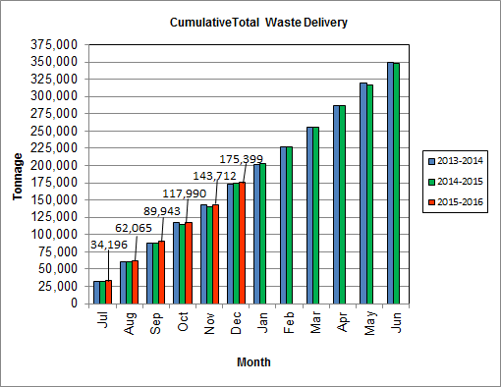

As depicted in Table 3 and Chart 8, for the period ending in November 2015; cumulative total waste delivery was 0.8% more compared to the same period in FY15.

Chart 9: Gross Electrical Generation

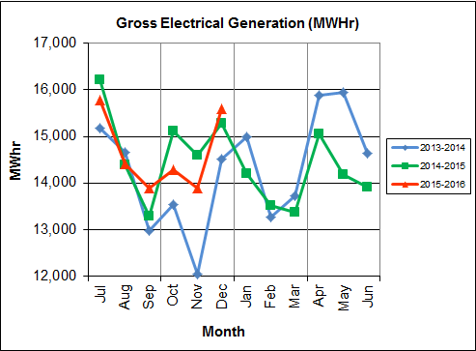

During Q2FY16, the Facility generated 43,757 MWhrs (gross) of electricity compared to Q2FY15 generation of 44,985 MWhrs (gross), a 2.7% decrease. The decrease in gross electrical generation in Q2FY16 as compared to Q2FY15 is attributable to the decrease in steam production, offset by less downtime (31.5 fewer hours) experienced by the Turbine Generators. Note that the sharp spikes depicted in Chart Nos. 10 through 14 for the months of May and June 2015 are a result of significant downtime (424.7 hours) experienced by Turbine Generator No. 1 to repair an exciter failure in the generator. A similar spike is depicted in the same charts for November 2013 as a result of Turbine Generator No. 2 experiencing significant downtime (494.8 hours) for a Major Overhaul.

Chart 10: Gross Conversion Rate

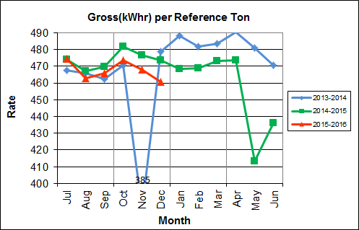

As shown in Chart 10, the average gross electrical generation per reference ton of refuse processed during Q2FY16 was 467 kWhr, which is 2.1% lower than the corresponding quarter in FY15. Since this calculated value uses reference or normalized tonnages of waste, it should cancel the effect of MSW heating value (Btu content) variability.

Chart 11: Net Conversion Rate

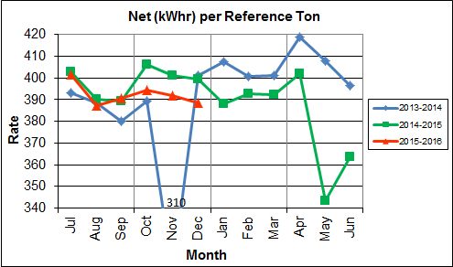

Chart 11 depicts the normalized net power (gross minus in-house usage) generation history. In Q2FY16, the average net electrical generation per reference ton was 392 kWhr, which is 2.7% lower than the corresponding quarter in FY15.

Chart 12: Net Conversion Rate

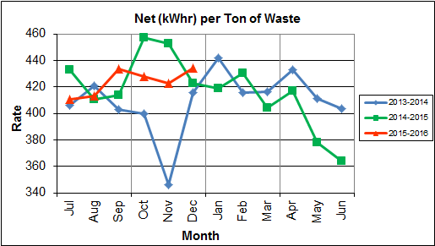

Chart 12 depicts the net power generation per processed ton. The net electrical generation per processed ton in Q2FY16 was 428 kWhr, which is 3.6% lower than the corresponding quarter in FY15.

Chart 13: Gross Turbine Generator Conversion Rate

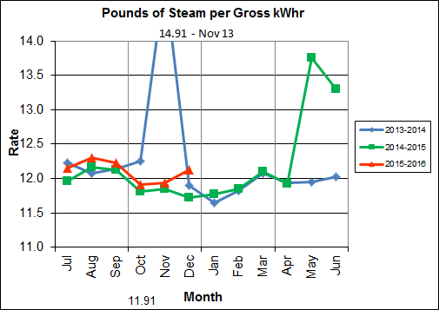

Charts 13 and 14 illustrate the quantities of steam required to generate one kWhr of electricity, gross and net respectively. This measure is a turbine generator performance indicator, where lower steam rates indicate superior performance. For simplification, this calculated rate is based on the average for the two turbine generators. In Q2FY16 the average lbs of steam consumed per gross kWhr generated was 12.0, which is higher (1.7%) than the corresponding quarter Q2FY15, and indicative of poorer performance. A contributing factor to the decline in this metric is Turbine Generator No. 2 continues to operate with its Stage 9 blades removed from the rotor. CAAI reported that during the Turbine Generator No. 2 overhaul in November 2013, some cracking was observed on the Stage 9 blades of the rotor, and the blading in that row was removed as a precautionary measure. CAAI originally indicated that a new set of blades would be manufactured and installed during a Turbine Generator No. 2 Outage in 2016, but advised in May 2015, that the implementation of the replacement blades installation would be delayed. The average lbs of steam consumed per net kWhr was 14.3, which is higher (2.3%) than the corresponding quarter in FY15. The average steam temperature during the quarter was 678.3° F, which is 0.1% lower than the average steam temperature of the corresponding quarter last year and 21.7° F lower than design temperature of 700o F.

Chart 14: Net Turbine Generator Conversion Rate

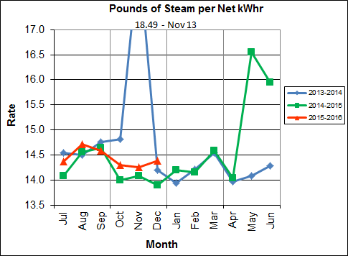

## Utility and Reagent Consumptions

Table 4: Facility Utility and Reagent Consumptions

|  |  |  |  |  |  |  |  |
| --- | --- | --- | --- | --- | --- | --- | --- |
| **Utility** | **Units** | **Q2FY16 Total** | **Q2FY15**  **Total** | **Q2FY16”Per Processed Ton” Consumption** | **Q2FY15”Per Processed Ton” Consumption** | **FY16**  **YTD Total** | **FY15**  **Total** |
| **Purchased Power** | MWhr | 5,560 | 5,500 | 0.06 | 0.06 | 11,037 | 22,001 |
| **Fuel Oil** | Gal. | 9,050 | 9,630 | 0.11 | 0.11 | 19,560 | 35,920 |
| **Boiler Make-up** | Gal. | 1,748,000 | 2,044,000 | 20.43 | 23.92 | 3,814,000 | 8,501,000 |
| **Cooling Tower Make-up** | Gal. | 35,132,772 | 33,436,464 | 410.56 | 391.27 | 77,373,039 | 143,594,395 |
| **Pebble Lime** | Lbs. | 1,396,000 | 1,384,000 | 16.31 | 16.20 | 2,730,000 | 5,254,000 |
| **Ammonia** | Lbs. | 167,000 | 159,000 | 1.95 | 1.86 | 333,000 | 632,000 |
| **Carbon** | Lbs. | 102,000 | 102,000 | 1.19 | 1.19 | 204,000 | 408,000 |
| **Dolomitic Lime** | Lbs. | 215,200 | 231,200 | 2.51 | 2.71 | 463,200 | 1,007,200 |

Fuel oil usage during the quarter represents approximately 0.16% of the total heat input to the boilers, which compares favorably with industry averages, and slightly lower than the percentage of heat input in Q2FY15 which was 0.17%. Fuel oil is used to stabilize combustion of wet fuel, as well as during start-up and shut-down of the boilers for maintenance. Boiler makeup water usage during the quarter represents 2.8% of steam flow, which is lower than the boiler makeup in Q2FY15 which was 3.2%, and is acceptable. Pebble lime usage, at 1,396,000 lbs. is higher (0.9%) than the corresponding quarter last year, and the quarterly consumption rate of 16.3 lbs/ton is comparable to historical levels (16-18 lbs/ton).

In comparing Q2FY16 to Q2FY15 on a per processed ton consumption basis:

* the purchased power consumption rate was 0.9% higher
* the total fuel oil consumption rate was 6.2% lower
* the boiler make-up water consumption rate was 14.6% lower
* the cooling tower make-up water consumption rate was 4.9% higher
* the total pebble lime consumption rate was 0.7% higher
* the ammonia consumption rate was 4.9% higher
* the carbon consumption rate was 0.1% lower
* the total dolomitic lime consumption rate was 7.1% lower[1]

## Safety & Environmental Training

The Facility had no recordable accidents during the quarter and has operated 1,777 days without an OSHA recordable incident through the end of September 2015. During the quarter, Safety and Environmental training was conducted with themes as follows:

**October 2015**

* Safety:
  + Confined Space Air Monitoring
  + Stretch and Flex
  + Grinding
* Environmental:
  + Water/Storm Water Best Management Practices (BMPs)
  + Storm Water Pollution Prevention Plan

**November 2015**

* Safety:
  + Hot Work
  + Scaffolding
  + Carbon Monoxide (CO) Monitoring
* Environmental:
  + Ash Generation and Treatment
  + Fugitive Emission
  + Ash Sampling and Transfer

**December 2015**

* Safety:
  + Hearing Conservation
  + Hazard Recognition/Prevention
* Environmental:
  + Electronics Recycling
  + Ash Reuse

# Facility Maintenance

Throughout the quarter, significant routine and preventative maintenance was performed. HDR considers that the Facility is implementing an effective maintenance regimen, and is performing routine and preventative maintenance, along with selected equipment replacements in a timely manner. CAAI monthly maintenance reports provide a detailed account of maintenance performed.

Beginning October 10th, Boiler No. 2 experienced 112.0 hours of downtime for scheduled maintenance. Some significant maintenance activities that occurred during the outage were:

* Modification of the atomizer lube oil cooler sump
* Replacement of the low and high boiler drum safety valves
* Repair of a crack in the generating bank hopper seam
* Replacement of two (2) curved boiler grate blocks on the ignition header
* Change-out of Sootblower Lances G9B Nos. 3, 8, and 9
* Installation of seven (7) tube shields in the superheater section
* Change-out of the motor on Sootblower G9B No. 27
* Repair of holes on Baghouse Hoppers B and D Cells
* Change-out of the coupling hub and sleeve on the fan side of the Induced Draft (ID) Fan

Beginning November 7th, Boiler No. 3 experienced 121.5 hours of downtime for scheduled maintenance. Some significant maintenance activities that occurred during the outage were:

* Modification of the atomizer lube oil cooler sump
* Replacement of the high boiler steam drum safety valve
* Repair of broken superheater vent line fitting on the 5th Floor
* Installation of new Sootblower auto valve on the 6th Floor
* Installation of a new ash discharger drain valve
* Replacement of the oil cooler on the hydraulic skid
* Change-out of four (4) wear plates in between the lower and upper doors on the north side of the ash discharger
* Repair of one (1) ash discharger ram arm
* Replacement of four (4) Sootblower elements on G9B Nos. 4, 5, 12, and 15
* Replacement of nine (9) curved blocks by the ignition roof header
* Re-plating of four (4) feet of the lower feed chute water jacket
* Change-out of the motor on the ID Fan
* Repair of several holes in the ID Fan Damper Wall
* Replacement of one (1) broken grate bar on Step No. 9 on Run No. 1
* Replacement of three (3) driving beam support rollers

In addition to the scheduled maintenance activities conducted on Boiler No. 1, CAAI reports that 1,121 preventative maintenance actions were completed during the quarter.

## Availability

Facility availabilities for Q2FY16 are shown in Table 5. According to CAAI reports, the average unit availabilities for Boiler Nos. 1, 2, and 3 for Q2FY16 were 100.0%, 94.6%, and 94.4%, respectively. The three-boiler average availability during the quarter was 96.3%, which is good.

During Q2FY16, the average availability for Turbine Generator Nos. 1 and 2 was 100.0%. The two-turbine generator average availability during the quarter was 100.0%, which is excellent.

Table 5: Quarterly Facility Unit Availabilities

|  |  |  |  |
| --- | --- | --- | --- |
| **Availability** | **Q1FY16 Average** | **Q2FY16 Average** | **FY16**  **YTD Average** |
| Boiler No. 1 | 94.1% | 100.0% | 97.0% |
| Boiler No. 2 | 97.9% | 94.6% | 96.3% |
| Boiler No. 3 | 98.5% | 94.4% | 96.5% |
| ***Avg.*** | ***96.8%*** | ***96.3%*** | ***96.6%*** |
| Turbine No. 1 | 99.0% | 100.0% | 99.5% |
| Turbine No. 2 | 99.1% | 100.0% | 99.5% |
| ***Avg.*** | ***99.0%*** | ***100.0%*** | ***99.5%*** |

## Downtime Summary

During Q2FY16, the Facility experienced one (1) instance of unscheduled downtime for the boilers totaling 7.1 hours, and no unscheduled downtime for the turbine generators. Beginning October 10, 2015, Boiler No. 2 experienced 112.0 hours of downtime for scheduled maintenance, and beginning November 7, 2015 Boiler No. 3 experienced 121.5 hours for scheduled maintenance. Note that Boiler No. 1 scheduled maintenance was conducted last quarter in the month of September. During Q2FY16, the boilers experienced two (2) instances of standby time totaling 84.8 hours, and Turbine Generator No. 1 experienced three (3) instances of standby time totaling 173.1 hours. Details of downtime events experienced during the quarter are portrayed in Tables 6 and 7:

Table 6: Boiler Downtime – Q2FY16

|  |  |  |  |  |  |  |
| --- | --- | --- | --- | --- | --- | --- |
| **Boiler Number** | **Outage Begin Date** | **Outage End Date** | **Hours Unavailable** | | **Downtime**  **Classification** | **Reason Unavailable** |
| 2 | 10/10/15 | 10/15/15 | 112.0 | | Scheduled | Fall 2015 Scheduled Boiler Outage |
| 2 | 10/15/15 | 10/17/15 | 60.0 | | Standby | Preventative measure taken to avoid exceeding 350,000 ton rolling 12-month process limit |
| 1 | 11/10/15 | 11/11/15 | 24.8 | | Standby | Preventative measure taken to avoid exceeding 350,000 ton rolling 12-month process limit |
| 3 | 11/7/15 | 11/12/15 | 121.5 | | Scheduled | Fall 2015 Scheduled Boiler Outage |
| 2 | 12/31/15 | 12/31/15 | 7.1 | | Unscheduled | ID Fan Coupling Failure |
| **Total Unscheduled Downtime** | | | | **7.1 Hours** | | |
| **Total Scheduled Downtime** | | | | **233.5 Hours** | | |
| **Total Standby Downtime** | | | | **84.8 Hours** | | |
| **Total Downtime** | | | | **325.4 Hours** | | |

Table 7: Turbine Generator Downtime – Q2FY16

|  |  |  |  |  |  |  |
| --- | --- | --- | --- | --- | --- | --- |
| **Turbine Generator Number** | **Outage Begin Date** | **Outage End Date** | **Hours Unavailable** | | **Downtime**  **Classification** | **Reason Unavailable** |
| 2 | 10/13/15 | 10/16/15 | 85.5 | | Standby | Boiler No. 2 down for outage and in standby for process limitations |
| 1 | 11/9/15 | 11/11/15 | 50.6 | | Standby | Boiler No. 3 down for outage and process limitations |
| 2 | 12/1/15 | 12/3/15 | 37.0 | | Standby | Dominion Virginia Power Scheduled Maintenance |
| **Total Unscheduled Downtime** | | | | **0.0 Hours** | | |
| **Total Scheduled Downtime** | | | | **0.0 Hours** | | |
| **Total Standby Downtime** | | | | **173.1 Hours** | | |
| **Total Downtime** | | | | **173.1 Hours** | | |

## Facility Housekeeping

CAAI is performing Facility housekeeping and maintaining plant cleanliness in accordance with acceptable industry practices. A site inspection was conducted in November 2015. At the time of the inspection, new deficiencies were recorded and prior deficiencies were given a status update. Photos of interest from the inspection are depicted in Appendix B. The Facility housekeeping ratings from the November 2015 inspection are presented in Table 8.

Table 8: Facility Housekeeping Ratings – August 2015

| **Facility Area** | **Acceptable** | **Needs Improvement** | **Unacceptable** |
| --- | --- | --- | --- |
| **Tipping Floor** |  | √(1) |  |
| **Citizen’s Drop-off Area** |  | √(2) |  |
| **Tipping Floor Truck Exit** | √ |  |  |
| **Front Parking Lot** | √ |  |  |
| **Rear Parking Lot** | √ |  |  |
| **Boiler House Pump Room** | √ |  |  |
| **Lime Slurry Pump Room** | √ |  |  |
| **Switchgear Area** | √ |  |  |
| **Ash Load-out Area** | √ |  |  |
| **Vibrating Conveyor Area** | √ |  |  |
| **Ash Discharger Area** | √ |  |  |
| **Cooling Tower Area** | √ |  |  |
| **Truck Scale Area** | √ |  |  |
| **SDA/FF Conveyor Area** | √ |  |  |
| **SDA Penthouses** | √ |  |  |
| **Lime Preparation Area** | √ |  |  |
| **Boiler Drum Levels** | √ |  |  |
| **Turbine Room** |  | √(3) |  |
| **Electrical Room** | √ |  |  |

**Note (1): Tipping Floor – Needs Improvement**

* Deteriorated Purlin

**Note (2): Citizen’s Drop-off Area – Needs Improvement**

* Damaged Curbing

**Note (3): Turbine Room – Needs Improvement**

* Ceiling panels corroded

# Environmental

The retrofit air pollution control equipment maintained emission concentrations well within the established regulations. Average Continuous Emission Monitoring System (CEMS) data collected for each monthly period during Q2FY16 are summarized in Appendix A. The Facility experienced one (1) permit deviation during the quarter.

On August 8, 2014, CAAI sent a letter to the Virginia Department of Environmental Quality (VADEQ) requesting relief from the steam permit limit requirements in the Facility’s Title V and PSD permits. These requested changes relate to the permit values established for the calculated steam-to-waste ratio, which has resulted in a reduction of MSW throughput. In recent discussions, CAAI indicated that it is re-evaluating options to the proposed permit changes, and will provide further updates on this issue.

On December 31, 2015, Boiler No. 2 experienced a permit deviation when 8-hour carbon injection levels decreased to 15.0 lbs/hr (16.0 lbs/hour minimum limit) as a result of an Induced Draft Fan Coupling Failure. CAAI reports that the corrective action taken was to replace the sheared coupling and inspect the equipment for proper operation.

A summary of the permit deviation experienced by the Facility during Q2FY16 is shown in Table 9 as follows.

Table 9: Quarterly Environmental Excursions

| **Date** | **Excursion** | **Exempt** |
| --- | --- | --- |
| 12/31/15 | Boiler No. 2 8-hour Carbon Injection Levels reached 15.0 lbs/hr (16.0 lbs/hr minimum limit) | Yes |

## Nitrogen Oxide Emissions

During Q2FY16, the monthly emission concentrations of nitrogen oxides (NOx) averaged 161.0 ppmdv, 162.0 ppmdv and 163.7 ppmdv for Boiler Nos. 1, 2, and 3, respectively. CAAI continues to operate the units at the lower (160 ppmdv) set-points, except immediately following a scheduled outage and associated boiler cleaning.

## Sulfur Dioxide Emissions

During Q2FY16 the monthly emission concentration of stack sulfur dioxide (SO2) averaged 0.3 ppmdv, 1.0 ppmdv, and 0.7 ppmdv for Boiler Nos. 1, 2, and 3, respectively. All of these stack SO2 concentrations are significantly below the 40 CFR Subpart Cb requirement of 29 ppmdv @ 7% O2.

## Carbon Monoxide Emissions

During Q2FY16, the average CO emission concentrations on Boiler Nos. 1, 2, and 3 were 35.7 ppmdv, 30.7 ppmdv, and 29.7 ppmdv, respectively, and all are well within permit limits (100 ppmdv, hourly average).

## Opacity

During Q2FY16, the average opacity for Boiler Nos. 1, 2, and 3 was 1.3%, 0.1%, and 0.8% respectively. All of these averages are significantly below the 10% (6-minute) average permit limit.

## Daily Emissions Data

Appendix A, Tables 11, 12, and 13 tabulate the monthly average, maximum, and minimum emissions data for each unit during Q2FY16. Excursions, if any, would appear in bold print. It should be noted that these tabulations of monthly averages, reported here for informational purposes, are based on tabulations of daily averages. These averages do not correlate with official reports to the regulatory agencies because of differences in averaging times and other technical differences required by agency report formats.

## Ash System Compliance

The dolomitic lime feed rate is adjusted periodically in order to maintain a desired ash pH level in the range of 8.0 to 11.0. Since initial startup, the feed rate has varied from between 1 to 9 lbs per ton. Ash Toxicity (TCLP) tests were performed for field samples collected over a seven (7) day period in October 2015, and results indicated that the average pH during testing was 9.5. Results from the TCLP testing conducted in October 2015 are depicted in Table 10 and Chart 15 below.

Table 10: Comparison of Statistical Results and Regulatory Thresholds for Metal Analytes

|  |  |  |  |  |  |
| --- | --- | --- | --- | --- | --- |
| **Metals** | **90% Upper Confidence**  **(October 2015)** | **90% Upper Confidence**  **(May 2015)** | **Regulatory Threshold (mg/L)** | **% of Threshold (October 2015)** | **% of Threshold (May 2015)** |
| **Arsenic** | 0.250 | 0.250 | 5.0 | 5.00% | 5.00% |
| **Barium** | 0.888 | 0.783 | 100.0 | 0.89% | 0.78% |
| **Cadmium** | 0.058 | 0.050 | 1.0 | 5.80% | 5.00% |
| **Chromium** | 0.250 | 0.250 | 5.0 | 5.00% | 5.00% |
| **Lead** | 0.250 | 0.250 | 5.0 | 5.00% | 5.00% |
| **Mercury** | 0.0002 | 0.0002 | 0.2 | 0.10% | 0.10% |
| **Selenium** | 0.050 | 0.050 | 1.0 | 5.00% | 5.00% |
| **Silver** | 0.250 | 0.250 | 5.0 | 5.00% | 5.00% |

Chart 15: Ash Toxicity Characteristic Leaching Procedure (TCLP) Results

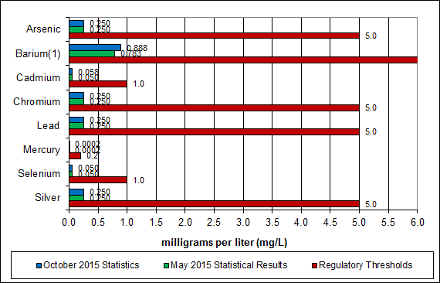

**Note: The regulatory threshold for Barium is 100 mg/L**

In addition to semi-annual TCLP testing, CAAI also samples ash monthly in-house, and documents pH readings to adjust dolomitic lime feed rate. The results for the ash pH tests are found below in Chart 16 where each quarter is represented by the average of the respective monthly readings. During Q2FY16, the average ash pH for in-house tests was 9.9, which is approaching the high end of the desired pH range.

Chart 16: Quarterly Ash Test Results

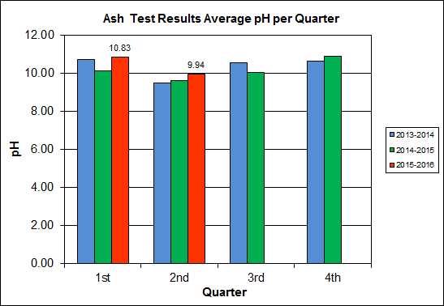

APPENDIX A  
FACILITY CEMS DATA

Table 11: Unit #1 Monthly Summary for Reportable Emissions Data

|  |  |  |  |  |  |  |  |  |  |  |
| --- | --- | --- | --- | --- | --- | --- | --- | --- | --- | --- |
| **Group#-Channel#** | | **G8-C35** | **G8-C28** | **G8-C8** | **G8-C4** | **G8-C12** | **G8-C34** | **G8-C37** | **G8-C40** | **G8-C39** |
| **Long Descrip.** | | **U-1 Steam** | **U-1 Econ** | **U-1 Stack** | **U-1 Stack** | **U-1 Stack** | **U-1 Opaci** | **U-1 FF In** | **U-1 Carbo** | **U-1 Lime** |
| **Short Descrip.** | | **SteamFl** | **SO2ec** | **SO2sc** | **COsc** | **NOxsc** | **Opacity** | **FF InTemp** | **CarbInj** | **LimeFlow** |
| **Units** | | **K#/Hr** | **ppmc** | **ppm** | **ppmc** | **ppmc** | **%** | **deg F** | **#/hr** | **gpm** |
| **Range** | | **0-100** | **0-2000** | **0-500** | **0-4000** | **0-1000** | **0-100** | **100-500** | **0-50** | **0-20** |
| Oct-15 | AVG | 80.7 | 36.0 | 0.0 | 31.0 | 162.0 | 1.1 | 301.0 | 16.3 | 3.0 |
| Max | 88.7 | 74.0 | 2.0 | 39.0 | 181.0 | 1.2 | 301.0 | 16.6 | 3.6 |
| Min | 70.5 | 20.0 | 0.0 | 24.0 | 157.0 | 0.9 | 301.0 | 16.0 | 2.8 |
| Nov-15 | AVG | 80.2 | 46.0 | 0.0 | 38.0 | 161.0 | 1.3 | 301.0 | 16.3 | 3.1 |
| Max | 88.1 | 67.0 | 6.0 | 52.0 | 168.0 | 1.8 | 302.0 | 16.5 | 3.5 |
| Min | 72.6 | 31.0 | 0.0 | 28.0 | 158.0 | 1.0 | 299.0 | 16.2 | 2.8 |
| Dec-15 | AVG | 81.9 | 34.0 | 1.0 | 38.0 | 160.0 | 1.4 | 303.0 | 16.3 | 3.0 |
| Max | 85.2 | 67.0 | 5.0 | 55.0 | 162.0 | 1.9 | 307.0 | 16.4 | 3.6 |
| Min | 62.3 | 18.0 | 0.0 | 25.0 | 155.0 | 1.2 | 302.0 | 16.2 | 2.8 |
| **Quarter Average** | | 80.9 | 38.7 | 0.3 | 35.7 | 161.0 | 1.3 | 301.7 | 16.3 | 3.0 |
| **Quarter Max Value** | | 88.7 | 74.0 | 6.0 | 55.0 | 181.0 | 1.9 | 307.0 | 16.6 | 3.6 |
| **Quarter Min Value** | | 62.3 | 18.0 | 0.0 | 24.0 | 155.0 | 0.9 | 299.0 | 16.0 | 2.8 |
| **Limits:** | | 98 | NA | 29 | 100 | 205 | 10 | 333 | 16(a) |  |

(a) Carbon flow limit is a minimum value

* Note: The data reported herein represent 24 hour average data for all parameters. Emissions excursions that are measured on shorter time intervals (i.e., 4-hour block averages for CO) do not correlate with the 24 hour average data reported above.

Table 12: Unit #2 Monthly Summary for Reportable Emissions Data

|  |  |  |  |  |  |  |  |  |  |  |
| --- | --- | --- | --- | --- | --- | --- | --- | --- | --- | --- |
| **Group#-Channel#** | | **G8-C35** | **G8-C28** | **G8-C8** | **G8-C4** | **G8-C12** | **G8-C34** | **G8-C37** | **G8-C40** | **G8-C39** |
| **Long Descrip.** | | **U-2 Steam** | **U-2 Econ** | **U-2 Stack** | **U-2 Stack** | **U-2 Stack** | **U-2 Opaci** | **U-2 FF In** | **U-2 Carbo** | **U-2 Lime** |
| **Short Descrip.** | | **SteamFl** | **SO2ec** | **SO2sc** | **COsc** | **NOxsc** | **Opacity** | **FF InTemp** | **CarbInj** | **LimeFlow** |
| **Units** | | **K#/Hr** | **ppmc** | **ppm** | **ppmc** | **ppmc** | **%** | **deg F** | **#/hr** | **gpm** |
| **Range** | | **0-100** | **0-2000** | **0-500** | **0-4000** | **0-1000** | **0-100** | **100-500** | **0-50** | **0-20** |
| Oct-15 | AVG | 82.3 | 53.0 | 1.0 | 26.0 | 167.0 | 0.2 | 301.0 | 16.3 | 3.1 |
| Max | 88.5 | 88.0 | 3.0 | 39.0 | 178.0 | 1.8 | 302.0 | 16.5 | 3.5 |
| Min | 71.2 | 30.0 | 0.0 | 13.0 | 156.0 | 0.0 | 300.0 | 16.2 | 2.9 |
| Nov-15 | AVG | 81.4 | 48.0 | 1.0 | 28.0 | 160.0 | 0.1 | 301.0 | 16.3 | 3.1 |
| Max | 88.2 | 75.0 | 3.0 | 39.0 | 163.0 | 0.3 | 302.0 | 16.5 | 3.6 |
| Min | 71.8 | 29.0 | 0.0 | 22.0 | 158.0 | 0.0 | 300.0 | 16.2 | 2.9 |
| Dec-15 | AVG | 82.7 | 37.0 | 1.0 | 38.0 | 159.0 | 0.0 | 301.0 | 16.3 | 3.1 |
| Max | 86.0 | 62.0 | 3.0 | 49.0 | 167.0 | 0.2 | 304.0 | 16.4 | 3.4 |
| Min | 62.5 | 20.0 | 0.0 | 19.0 | 155.0 | 0.0 | 299.0 | 16.1 | 2.9 |
| **Quarter Average** | | 82.1 | 46.0 | 1.0 | 30.7 | 162.0 | 0.1 | 301.0 | 16.3 | 3.1 |
| **Quarter Max Value** | | 88.5 | 88.0 | 3.0 | 49.0 | 178.0 | 1.8 | 304.0 | 16.5 | 3.6 |
| **Quarter Min Value** | | 62.5 | 20.0 | 0.0 | 13.0 | 155.0 | 0.0 | 299.0 | 16.1 | 2.9 |
| **Limits:** | | 96 | NA | 29 | 100 | 205 | 10 | 330 | 16(a) |  |

(a) Carbon flow limit is a minimum value

* Note: The data reported herein represent 24 hour average data for all parameters. Emissions excursions that are measured on shorter time intervals (i.e., 4-hour block averages for CO) do not correlate with the 24 hour average data reported above.

Table 13: Unit #3 Monthly Summary for Reportable Emissions Data

|  |  |  |  |  |  |  |  |  |  |  |
| --- | --- | --- | --- | --- | --- | --- | --- | --- | --- | --- |
| **Group#-Channel#** | | **G8-C35** | **G8-C28** | **G8-C8** | **G8-C4** | **G8-C12** | **G8-C34** | **G8-C37** | **G8-C40** | **G8-C39** |
| **Long Descrip.** | | **U-3 Steam** | **U-3 Econ** | **U-3 Stack** | **U-3 Stack** | **U-3 Stack** | **U-3 Opaci** | **U-3 FF In** | **U-3 Carbo** | **U-3 Lime** |
| **Short Descrip.** | | **SteamFl** | **SO2ec** | **SO2sc** | **COsc** | **NOxsc** | **Opacity** | **FF InTemp** | **CarbInj** | **LimeFlow** |
| **Units** | | **K#/Hr** | **ppmc** | **ppm** | **ppmc** | **ppmc** | **%** | **deg F** | **#/hr** | **gpm** |
| **Range** | | **0-100** | **0-2000** | **0-500** | **0-4000** | **0-1000** | **0-100** | **100-500** | **0-50** | **0-20** |
| Oct-15 | AVG | 82.3 | 30.0 | 0.0 | 31.0 | 159.0 | 0.1 | 305.0 | 16.4 | 3.2 |
| Max | 90.0 | 65.0 | 4.0 | 45.0 | 166.0 | 1.1 | 306.0 | 16.5 | 3.6 |
| Min | 70.0 | 19.0 | 0.0 | 18.0 | 157.0 | 0.0 | 303.0 | 16.3 | 3.0 |
| Nov-15 | AVG | 82.9 | 55.0 | 1.0 | 26.0 | 172.0 | 0.9 | 306.0 | 16.4 | 3.1 |
| Max | 93.0 | 105.0 | 6.0 | 37.0 | 179.0 | 1.6 | 307.0 | 16.5 | 3.4 |
| Min | 73.5 | 28.0 | 0.0 | 19.0 | 158.0 | 0.0 | 305.0 | 16.3 | 2.6 |
| Dec-15 | AVG | 87.1 | 47.0 | 1.0 | 32.0 | 160.0 | 1.3 | 304.0 | 16.4 | 3.1 |
| Max | 91.1 | 80.0 | 3.0 | 45.0 | 162.0 | 1.8 | 309.0 | 16.8 | 3.3 |
| Min | 63.3 | 34.0 | 0.0 | 19.0 | 157.0 | 1.0 | 301.0 | 16.2 | 3.0 |
| **Quarter Average** | | 84.1 | 44.0 | 0.7 | 29.7 | 163.7 | 0.8 | 305.0 | 16.4 | 3.1 |
| **Quarter Max Value** | | 93.0 | 105.0 | 6.0 | 45.0 | 179.0 | 1.8 | 309.0 | 16.8 | 3.6 |
| **Quarter Min Value** | | 63.3 | 19.0 | 0.0 | 18.0 | 157.0 | 0.0 | 301.0 | 16.2 | 2.6 |
| **Limits:** | | 98 | NA | 29 | 100 | 205 | 10 | 327 | 16(a) |  |

(a) Carbon flow limit is a minimum value

* Note: The data reported herein represent 24 hour average data for all parameters. Emissions excursions that are measured on shorter time intervals (i.e., 4-hour block averages for CO) do not correlate with the 24 hour average data reported above.

APPENDIX B  
SITE PHOTOS – NOVEMBER 2015

|  |  |
| --- | --- |
| C:\Users\kperrin\Desktop\November 2015\P1010864.JPG  Figure 1: Ash Trailers (typical of 3) have a damaged top pressure-treated wood rail (2”x6”) – New Deficiency | C:\Users\kperrin\Desktop\November 2015\P1010910.JPG  Figure 2: Ceiling panels corroded, above Condensate Make-up Tank – Painting Item – New Deficiency |
| C:\Users\kperrin\Desktop\November 2015\P1010917.JPG  Figure 3: Pressure treated support split at bolt, on Cooling Tower Access Stairs – New Deficiency | C:\Users\kperrin\Desktop\November 2015\P1010852.JPG  Figure 4: Cooling Towers from SDA Penthouse |
| C:\Users\kperrin\Desktop\November 2015\P1010856.JPG  Figure 5: New Opacity Monitor being installed on Boiler No. 3 | C:\Users\kperrin\Desktop\November 2015\P1010906.JPG  Figure 6: New Opacity Monitor Panel inside CEMS Enclosure |
| C:\Users\kperrin\Desktop\November 2015\P1010857.JPG  Figure 7: Ferrous Magnet – No Issues Observed | C:\Users\kperrin\Desktop\November 2015\P1010858.JPG  Figure 8: Boiler No. 3 Grate - Offline for Fall Outage |
| C:\Users\kperrin\Desktop\November 2015\P1010859.JPG  Figure 9: Outage Materials at Grate Access Elevation | C:\Users\kperrin\Desktop\November 2015\P1010861.JPG  Figure 10: Refractory Tile awaiting installation |
| C:\Users\kperrin\Desktop\November 2015\P1010862.JPG  Figure 11: Ash Trailer Canopy | **C:\Users\kperrin\Desktop\November 2015\P1010867.JPG**  Figure 12: Tipping Floor Entrance – Recently resurfaced – No Issues Observed |
| C:\Users\kperrin\Desktop\November 2015\P1010868.JPG  Figure 13: Metal Drop-off | C:\Users\kperrin\Desktop\November 2015\P1010869.JPG  Figure 14: Facility Scales – No Issues Observed |
| C:\Users\kperrin\Desktop\November 2015\P1010870.JPG  Figure 15: Citizen’s Drop-Off | C:\Users\kperrin\Desktop\November 2015\P1010872.JPG  Figure 16: Drainage Grate at Truck Entrance to Facility – New epoxy application being tested |
| C:\Users\kperrin\Desktop\November 2015\P1010875.JPG  Figure 17: General Facility View from east looking west | C:\Users\kperrin\Desktop\November 2015\P1010878.JPG  Figure 18: General Facility View – Front of Facility Facing Eisenhower |
| C:\Users\kperrin\Desktop\November 2015\P1010882.JPG  Figure 19: General Facility View – From west looking east | C:\Users\kperrin\Desktop\November 2015\P1010914.JPG  Figure 20: Dolomitic Lime Silo – No Issues Observed |
| C:\Users\kperrin\Desktop\November 2015\P1010892.JPG  Figure 21: Tipping Floor – No Issues Observed | C:\Users\kperrin\Desktop\November 2015\P1010915.JPG  Figure 22: Economizers & Spray Dryer Absorbers (SDAs) |
| C:\Users\kperrin\Desktop\November 2015\P1010899.JPG  Figure 23: Refuse Pit – From north looking south | C:\Users\kperrin\Desktop\November 2015\P1010855.JPG  Figure 24: Baghouse Compartment Aisle – No Issues Observed |

1. CAAI reports that the dolomitic lime consumption data previously provided via the monthly operating reports are incorrect. The value reported herein is derived from a separate reagent report. The correction of prior incorrect data for this parameter will be discussed at the forthcoming FMG meeting.